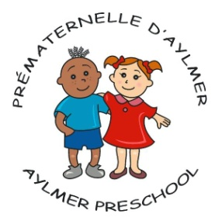

Consent for the publication and use of an image and/or child’s name
As a person of full age I hereby expressly authorize the Aylmer Preschool to use the photographed or filmed image of the minor person whom I legally represent for use and publication in printed or electronic materials such as newspapers, newsletters, social media, and other similar fundraising documents from year to year without compensation.

I waive the Aylmer Preschool or any and all claims arising out of the use and/or publication by anyone, including third parties, of said document.

Child’s Name: (block letters)__________________________________________
Full legal name of legal representative: (block letters)
__________________________________________________________________
Signature of consent of representative:___________________________________
Date: __________________________________________________________________

